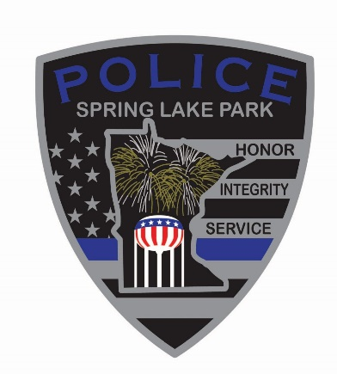 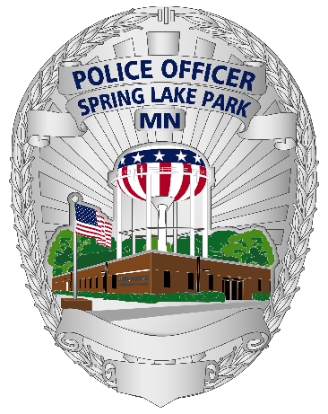

**Job Announcement**

City: Spring Lake Park, Minnesota

Position: Police Officer

Date: March 21, 2022

Description:

The Spring Lake Park Police Department is accepting applications for a “Police Officer Position” for **one current opening**. We will also be establishing an eligibility list for an expected future opening in 2022. Applicants must fulfill minimum selection standards of the Minnesota POST Board and must possess or be eligible to possess a Full-Time Minnesota Peace Officer license by the time of appointment. Applicants must present a detailed resume with their completed application, and if applicable, a” Veteran’s DD214 form” by **April 7, 2022 @ 4:00 P.M**.

The City of Spring Lake Park Police Department current pay scale for a police officer position is

$33.82 to $ 44.56. **Lateral transfers are encouraged and will be evaluated on a case by case basis.**

Applications can be obtained at the Spring Lake Park Police Department, Monday thru Friday at 1301 81st Ave NE, Spring Lake Park, MN 55432, during business hours (8 am to 4:30 pm) or on the City of Spring Lake Park Website (slpmn.org/city-services.html). **Applications received after *Monday, April 7, 2022 at 4:00 P.M.* will be declined.**

**Application deadline: Monday, April 7, 2022 @ 4:00 P.M.**